Contents

Introduction 2

State of the art and references 2

1. Raspberry Pi 2

2. Sense Hat 2

3. Watson IOT Platform 2

Network Diagram 3

Configuration parameters 3

1. Connecting devices to the Watson IOT platform 3

2. Publish Client 4

3. Managing Data Dashboard 5

4. Subscribe Client 5

5. Database design 5

Methodology and Results 5

Conclusion 6

References 6

Sense Hat Sensor Signals with Watson IOT Platform and Raspberry Pi

Lai Trung Quan

# Introduction

Nowadays, technology has poised for a huge leap forward in the name of the Internet of Things. The internet has been around for a while, but it has been mostly the product of people, so all the data, images, recordings, games, books and commerce were created by people. The internet is one of the most important and transformative technologies ever invented. It is not just about connecting people, it is also about connecting things because things can start to share their experiences with other things. People can add the ability to send, communicate as well as touch and control then things can get an opportunity to interact and collaborate with other things. In this project, Raspberry PI would be used as a computing device and Sense Hat which is attached on top of Raspberry PI. The Sense Hat has various sensors such as temperature, humidity, pressure as well as gyroscope which would be sent over these signals to Watson IoT Platform as a broker using MQTT protocol. There will be two MQTT clients setting up on Raspberry PI, one is Publish Client which is used to publish sensor data from Sense Hat sensors to broker and another one is Subscribe Client using to receive sensor signals from broker and display on Sense Hat led screen. Data can be read from the broker dashboard as well as Subscribe Client.

# State of the art and references

## Raspberry Pi

Raspberry PI is various of small single board computer which has additional features such as Bluetooth, Wi-Fi, USB, input/output port and so on. It is also a low-cost computer which can be plugged into any monitor as well as including a keyboard and mouse. It could be the best option for programming learners to explore and understand at the beginning. The latest version available is Raspberry PI 3 which was released in February 2016. The combination between Raspbian operation and PI which stands for Python programming language. There are various powerful things which are built-in Raspberry PI. It enables people to browse the Internet as well as watch HD videos which supported an HDMI port, apart from that even basic operation such as making spreadsheets, creating words and so forth, all these can be done on Raspberry PI. Besides that, there are a huge set of games that are available which making it quite interesting and easy for people to enjoy the component. Then various add-on capabilities such as infrared camera and security system which can be built keeping Raspberry PI as the core hardware. It also provides an Ethernet connector following which there are four USB slots, as well as an important part, is GPIO pins and micro USB slot which used to install the operating system. Those are some key top capabilities of Raspberry PI which help to become one of the biggest components.

## Sense Hat

This is one of the most popular and interesting accessories to Raspberry PI because there are various onboard sensors and joysticks as well. It is also quite popular because of the 8x8 LED matrix which can be used to display a lot of things. One of the easiest and useful things is that it can directly be assembled on top of the Raspberry PI GPIO pins.

## Watson IOT Platform

Watson IOT platform enables to securely connect to all types of devices from chips to intelligent implant appliances to the cloud platform using IBM Bluemix. It is simple to connect and collect data from devices as well as support built-in lifecycle management.

There are three core services on The Watson IOT Platform: Connection Service, Analytics Service, and Blockchain Service. However, Connection Service will be focused on in term of this project. This is a platform for any IOT project that requires the interstation of data from devices, the storage of that data for analytics. IOT connection service simplifies the IOT process as a fully managed software as a services solution, users can allocate resources elsewhere to save time, resources and cost associated. There are five main essential services: connect, collect, register, analyze and archive data quickly and securely [1]

# Network Diagram

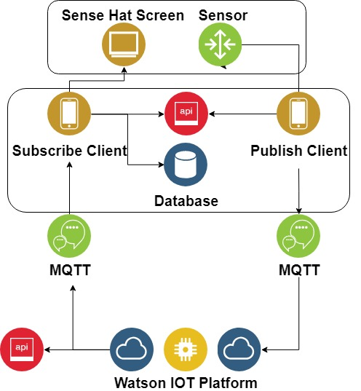

# Configuration parameters

## Connecting devices to the Watson IOT platform

The IOT platform is the endpoint where devices send data to and send these data to subscribe to clients. Logging into IBM Bluemix and starting IOT platform:

* On the main board select Devices then click Add Devices
* Define Device Type and Device ID (Device Type is a kind of group function to group devices together with similar characteristics). This information needs to use later in communication between an application and an IOT platform.
* At this point, let Bluemix determine token but it can be defined by users. the token is only shown once during the configuration. Users must register the device again in case of losing the token key.

Three different devices will be added to receive different signals from Publish Client:

* D001: temperature, humidity and pressure signals
* D002: Joystick button
* D003: Magnetometer

Formatting for Device ID and Hostname will be:

Device ID: *d:org_id:device_type:device_id*

Hostname: *org_id.messaging.internetofthings.ibmcloud.com*

Now It is ready to connect to Watson IOT platform using the above information. However, in this project API key will be used instead for security purposes.

By moving to Apps tab then click generate API key button. This API key is also shown once during the configuration. The client needs to authentication themselves with an API key. The Watson IOT Platform support TLS version 1.2 by default [2]

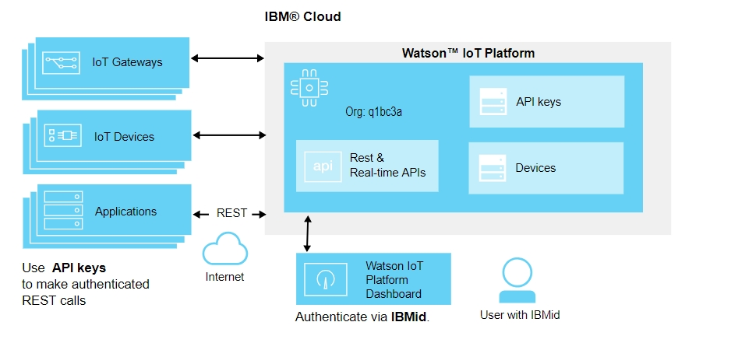

## Publish Client

In this project, Python will be selected as a programming language and uses ibmiotf library to interact with Watson IBM Platform [3].

This library can be installed via terminal console: *pip install ibmiotf*

Firstly, the device needs to provide necessary definitions which are created when adding new devices on IBM platform such as *orgId, appId, auth-method, auth-key, auth-token.* Client ID D001 will be used to publish signals to broker.

The command will be:

*myClient.publishEvent("SensorHome","D001","PreTemHu","json", myData)*

In this case, Json format is used for sending data.

Signals will be collected from Sense Hat device which using sense_hat library to interact with then sending these signals through IBM broker using port 8883 which data will be encrypted.

## Managing Data Dashboard

The IBM Platform provides Live Dashboard to manage data sending to broker. By using Board option on the main page then click Create New Board. There is plenty of Card Type available such as Line Chart, Bar Chart, Value and so on. After that, selecting Device to get data and data set which will be shown on the dashboard later.

This is a useful feature to visualize the collected data for analytic and management purposes.

## Subscribe Client

The similarity to Publish Client, Subscribe Client need to be connected to IBM Cloud using necessary information. Another Client ID D002 is used to subscribe to the broker and get data from it. When the connection is finished, the client is ready to subscribe to events from devices. Subscribe client can subscribe to specific events or devices by using parameters to control the output of subscription [3].

To handle events which are received from the broker, an event callback method needs to be registered [3].

After that, these signals will be shown on Sense Hat screen by using display message function and the Joystick button is used to switch between these signals.

## Database design

MySQL server is installed on Raspberry PI to store signal data. Then creating a database names IOTDB and three different tables to store data from three devices: D001, D002, and D003. There are four fields in the table:

* id: integer type, auto increment
* text: event name
* value: event data
* timestamp: event timestamp

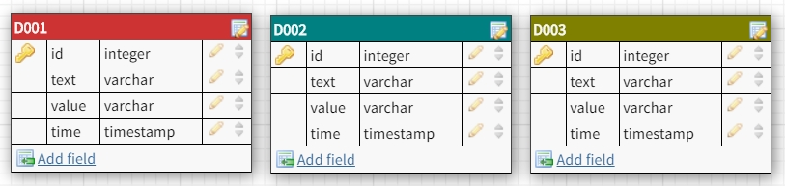

# Methodology and Results

In this project, MQTT was used to send to and receive signals from the broker (The Watson IOT Platform). MQTT is known as a lightweight messaging protocol that allows devices to communicate with any MQTT broker. Basically, there are three parts of an MQTT transmission: message, topic, and QoS (Quality of service).

The broker knows a lot about these clients such as which clients have connected to it in the past and remember it by the client ID and it also knows which clients are subscribed at which topics as well as knows which clients are currently connected because those clients send a keep-alive message to the broker at a specific time interval. The keep-alive timeout is set by MQTT broker and by default it is 60 seconds. If the client goes 60 seconds without sending an MQTT message, the broker will ping that client to see if it is still connected [4]

The Sense Hat captures signals from the environment such as temperature, humidity and pressure then these signals will be published as a message to the defined topic sch as SensorHome\D001\PreTemHu which was defined on IBM Cloud. This process involves three steps. Firstly, the publishing client which was configured by using Python and ibmiotf library publish a message. This message is sent to MQTT broker and this broker will post the message to that specific topic. After that, the subscribing client subscribes to that topic will then receive the message and display the content on Sense Hat screen.

# Conclusion

The Internet of Things has changed much about the world from making purchases, communication even getting signals to turn smart home devices on. By connecting to Cloud services, IBM IOT platform provides plenty of services which helping from receive and collect data to store and analyst for any purposes as well as security options to encrypt and secure coming data. Combination with MQTT that is one of the most popular protocols which used on the top of the TCP/IP protocol, it is convenient for real-time communication between embedded devices such as Sense Hat which attached on top of Raspberry Pi. Necessary action would be taken immediately by monitoring the changing of different signals.

# References

|  |  |
| --- | --- |
| [1] | IBM, „Product overview,“ IBM, [Online]. Available: https://www.ibm.com/support/knowledgecenter/en/SSQP8H/iot/overview/overview.html. |
| [2] | „Watson IoT Platform security,“ IBM, 27 02 2018. [Online]. Available: https://console.bluemix.net/docs/services/IoT/reference/security/index.html#platform-security. |
| [3] | „Python for application developers,“ IBM, 11 01 2018. [Online]. Available: https://console.bluemix.net/docs/services/IoT/applications/libraries/python.html#python. |
| [4] | „MQTT Messaging,“ IBM, 21 02 2018. [Online]. Available: https://console.bluemix.net/docs/services/IoT/reference/mqtt/index.html#mqtt-keep-alive. |